

**Miakara**

**Makers**

| **MATERIAL & SUPPLY COMPANY IDENTIFICATION** |
| --- |

## **Product Identifiers**

| Product Name: | Decyl Glucoside |
| --- | --- |
| Chemical Name: | Decyl Glucoside |
| CAS Number:  INCI: | 58846-77-8  Decyl Glucoside |

## **Relevant identified uses of the substance or mixture**

Cosmetics.

## **Supplier Details**

| Supplier: | Miakara Makers |
| --- | --- |
| Address: | 3/27 Graystone Ct, Epping Vic 3076 |
| Telephone: | 0488113230 |
|  |  |

## **Information in case of emergency**

| Poisons Information Centre | 13 11 26 |
| --- | --- |

| **HAZARD IDENTIFICATION** |
| --- |

## **Classification of the substance / preparation**

HAZARDOUS CHEMICAL. NON-DANGEROUS GOODS. According to the WHS Regulations and the ADG Code.

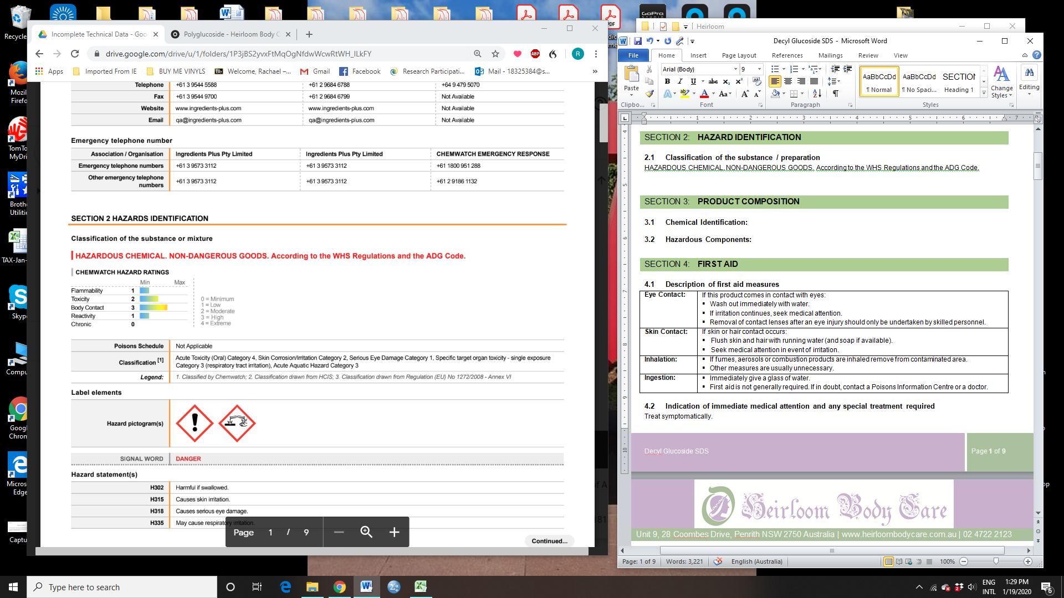

**Poisons Schedule:** Not applicable

**Classification:** Acute Toxicity (Oral) Category 4, Skin Corrosion/Irritation Category 2, Serious Eye Damage Category 1, Specific target organ toxicity - single exposure Category 3 (respiratory tract irritation), Acute Aquatic Hazard Category 3

**Label Elements:  
Hazard Pictograms**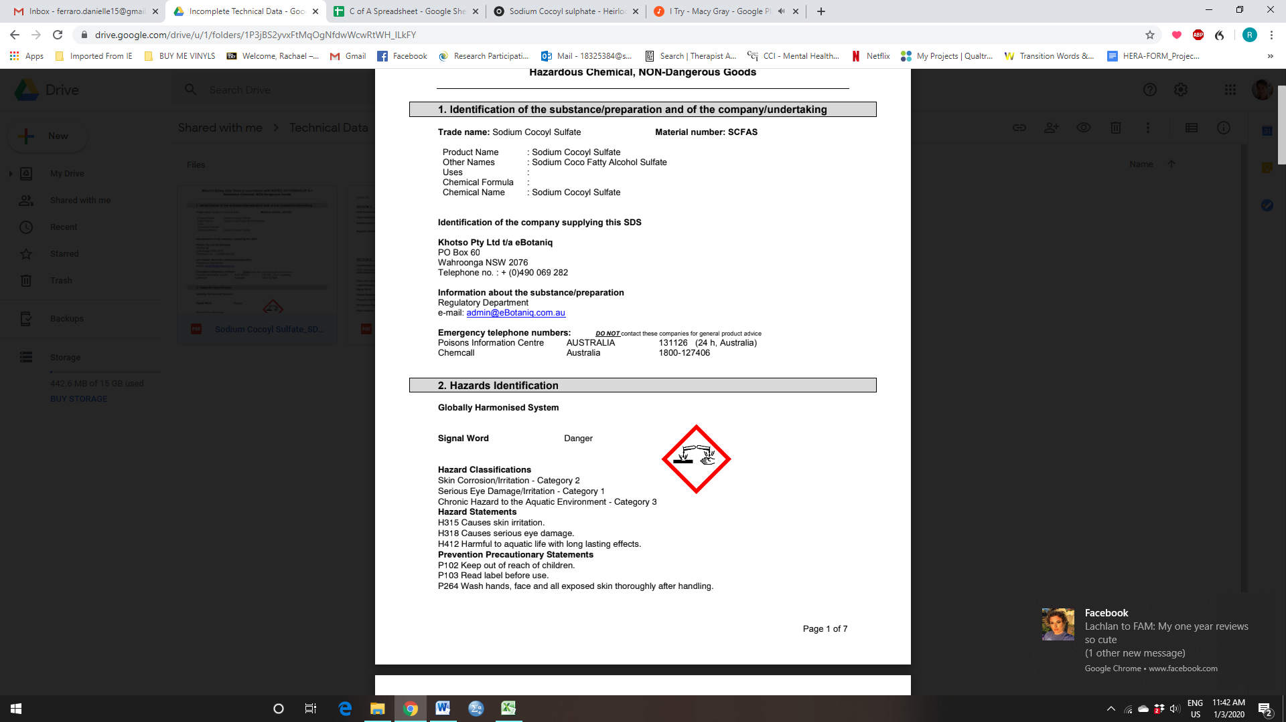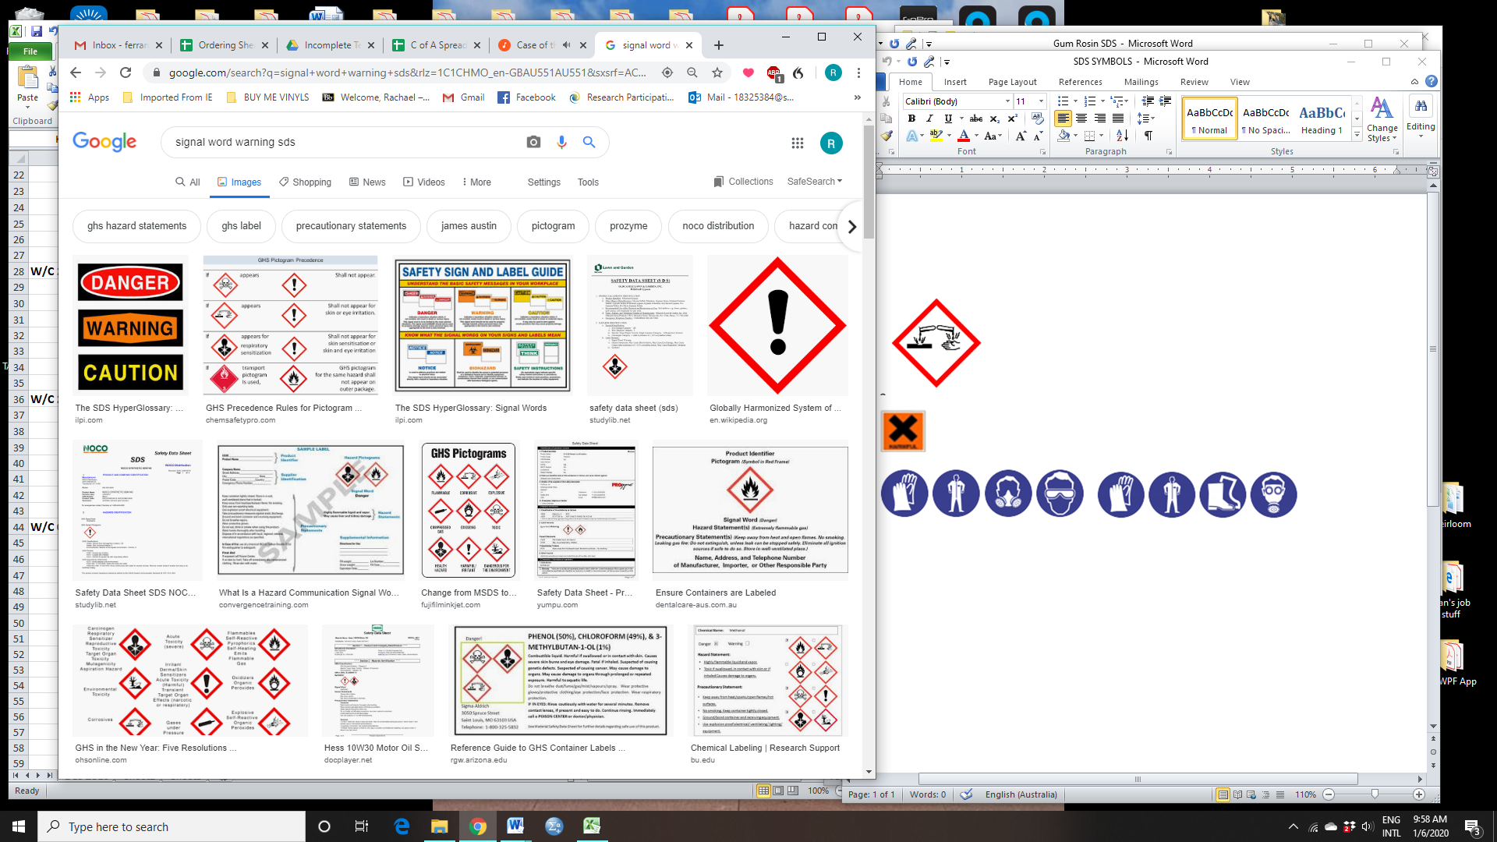

**Signal Word:** Danger

**Hazard Statements:**

H302 Harmful if swallowed.  
 H315 Causes skin irritation.  
 H318 Causes serious eye damage.  
 H335 May cause respiratory irritation.  
 H402 Harmful to aquatic life.

**Precautionary Statements Prevention:**

P271 Use only outdoors or in a well-ventilated area.  
 P280 Wear protective gloves/protective clothing/eye protection/face protection.  
 P261 Avoid breathing mist/vapours/spray.  
 P270 Do not eat, drink or smoke when using this product.  
 P273 Avoid release to the environment.

**Precautionary Statements Response:**

P305+P351+P338 IF IN EYES: Rinse cautiously with water for several minutes. Remove contact  
 lenses, if present and easy to do. Continue rinsing.  
 P310 Immediately call a POISON CENTER or doctor/physician.  
 P362 Take off contaminated clothing and wash before reuse.  
 P301+P312 IF SWALLOWED: Call a POISON CENTER or doctor/physician if you feel unwell.  
 P302+P352 IF ON SKIN: Wash with plenty of soap and water.  
 P304+P340 IF INHALED: Remove victim to fresh air and keep at rest in a position comfortable for  
 breathing.  
 P330 Rinse mouth.  
 P332+P313 If skin irritation occurs: Get medical advice/attention.

**Precautionary Statements Storage:**

P405 Store locked up.  
 P403+P233 Store in a well-ventilated place. Keep container tightly closed**.**

**Precautionary Statements Disposal:**

P501 Dispose of contents/container in accordance with local regulations.

| **PRODUCT COMPOSITION** |
| --- |

## **Substances:**

See section below for composition of Mixtures.

## **Mixtures:**

| **CAS No:** | **%[weight]** | **Name** |
| --- | --- | --- |
| 110615-47-9 | 20-40 | (C10-16)alkyl D-glycopyranoside |
| 68515-73-1 | 15-35 | decyl-D-glucopyranoside |

| **FIRST AID** |
| --- |

## **Description of first aid measures**

| **Eye Contact:** | If this product comes in contact with eyes:   * Immediately hold eyelids apart and flush the eye continuously with running water. * Ensure complete irrigation of the eye by keeping eyelids apart and away from eye and moving the eyelids by occasionally lifting the upper and lower lids. * Continue flushing until advised to stop by the Poisons Information Centre or a doctor, or for at least 15 minutes. * Transport to hospital or doctor without delay. * Removal of contact lenses after an eye injury should only be undertaken by skilled personnel. |
| --- | --- |
| **Skin Contact:** | If skin or hair contact occurs:   * Immediately remove all contaminated clothing, including footwear. * Flush skin and hair with running water (and soap if available). * Seek medical attention in event of irritation. |
| **Inhalation:** | * If fumes or combustion products are inhaled remove from contaminated area. * Lay patient down. Keep warm and rested. * Prostheses such as false teeth, which may block airway, should be removed, where possible, prior to initiating first aid procedures. * Apply artificial respiration if not breathing, preferably with a demand valve resuscitator, bag-valve mask device, or pocket mask as trained. * Perform CPR if necessary. * Transport to hospital, or doctor, without delay. |
| **Ingestion:** | * **IF SWALLOWED, REFER FOR MEDICAL ATTENTION, WHERE POSSIBLE, WITHOUT DELAY**. * For advice, contact a Poisons Information Centre or a doctor. * Urgent hospital treatment is likely to be needed. * In the meantime, qualified first-aid personnel should treat the patient following observation and employing supportive measures as indicated by the * patient's condition. * If the services of a medical officer or medical doctor are readily available, the patient should be placed in his/her care and a copy of the SDS should be provided. Further action will be the responsibility of the medical specialist. * If medical attention is not available on the worksite or surroundings send the patient to a hospital together with a copy of the SDS. * Where medical attention is not immediately available or where the patient is more than 15 minutes from a hospital or unless instructed otherwise: * INDUCE vomiting with fingers down the back of the throat, ONLY IF CONSCIOUS. Lean patient forward or place on left side (head-down position, if possible) to maintain open airway and prevent aspiration. * NOTE: Wear a protective glove when inducing vomiting by mechanical means. |

## **Indication of immediate medical attention and any special treatment required**

Treat symptomatically.

| **FIRE FIGHTING MEASURES** |
| --- |

## **Extinguishing Media**

* Water spray or fog.
* Foam.
* Dry chemical powder.
* BCF (where regulations permit).
* Carbon dioxide.

**Do not** use water jets.

## **Special hazards arising from the substance or mixture**

**Fire Incompatibility:** Avoid contamination with oxidising agents i.e. nitrates, oxidising acids, chlorine bleaches, pool chlorine etc. as ignition may result

## **Advice for firefighters**

| **Fire Fighting** | * Alert Fire Brigade and tell them location and nature of hazard. * Wear full body protective clothing with breathing apparatus. * Prevent, by any means available, spillage from entering drains or water course. * Use water delivered as a fine spray to control fire and cool adjacent area. * Avoid spraying water onto liquid pools. * DO NOT approach containers suspected to be hot. * Cool fire exposed containers with water spray from a protected location. * If safe to do so, remove containers from path of fire. |
| --- | --- |
| **Fire/Explosion Hazard** | * Combustible. * Slight fire hazard when exposed to heat or flame. * Heating may cause expansion or decomposition leading to violent rupture of containers. * On combustion, may emit toxic fumes of carbon monoxide (CO). * May emit acrid smoke. * Mists containing combustible materials may be explosive.   Combustion products include:   * carbon dioxide (CO2) * other pyrolysis products typical of burning organic material. * May emit poisonous fumes. * May emit corrosive fumes. |
| **HAZCHEM** | Not Applicable |

| **ACCIDENTAL RELEASE MEASURES** |
| --- |

## **Personal precautions, protective equipment and emergency procedures**

See section 8

## **Environmental precautions**

See section 12

## **Methods and materials for containment and cleaning up**

| **Minor Spills** | * Remove all ignition sources. * Clean up all spills immediately. * Avoid breathing vapours and contact with skin and eyes. * Control personal contact with the substance, by using protective equipment. * Contain and absorb spill with sand, earth, inert material or vermiculite. * Wipe up. * Place in a suitable, labelled container for waste disposal. * Slippery when spilt. |
| --- | --- |
| **Major Spills** | * Moderate hazard. * Clear area of personnel and move upwind. * Alert Fire Brigade and tell them location and nature of hazard. * Wear breathing apparatus plus protective gloves. * Prevent, by any means available, spillage from entering drains or water course. * No smoking, naked lights or ignition sources. * Increase ventilation. * Stop leak if safe to do so. * Contain spill with sand, earth or vermiculite. * Collect recoverable product into labelled containers for recycling. * Absorb remaining product with sand, earth or vermiculite. * Collect solid residues and seal in labelled drums for disposal. * Wash area and prevent runoff into drains. * If contamination of drains or waterways occurs, advise emergency services. * Slippery when spilt. |

Personal Protective Equipment advice is contained in Section 8 of the SDS.

| **HANDLING AND STORAGE** |
| --- |

## **Precautions for safe handling**

| **Safe handling** | * DO NOT allow clothing wet with material to stay in contact with skin * Avoid all personal contact, including inhalation. * Wear protective clothing when risk of exposure occurs. * Use in a well-ventilated area. * Prevent concentration in hollows and sumps. * DO NOT enter confined spaces until atmosphere has been checked. * Avoid smoking, naked lights or ignition sources. * Avoid contact with incompatible materials. * When handling, DO NOT eat, drink or smoke. * Keep containers securely sealed when not in use. * Avoid physical damage to containers. * Always wash hands with soap and water after handling. * Work clothes should be laundered separately. * Use good occupational work practice. * Observe manufacturer's storage and handling recommendations contained within this SDS. * Atmosphere should be regularly checked against established exposure standards to ensure safe working conditions. |
| --- | --- |
| **Other information** | * Store in original containers. * Keep containers securely sealed. * No smoking, naked lights or ignition sources. * Store in a cool, dry, well-ventilated area. * Store away from incompatible materials and foodstuff containers. * Protect containers against physical damage and check regularly for leaks. * Observe manufacturer's storage and handling recommendations contained within this SDS. |

## **Conditions for storage**

| **Suitable container** | * Metal can or drum * Packaging as recommended by manufacturer. * Check all containers are clearly labelled and free from leaks. |
| --- | --- |
| **Storage incompatibility** | * Avoid reaction with oxidising agents * Avoid storage with reducing agents. * Avoid strong acids, bases. |

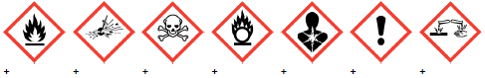

X — Must not be stored together

0 — May be stored together with specific preventions

+ — May be stored together

| **EXPOSURE CONTROLS AND PERSONAL PROTECTION** |
| --- |

## **Control parameters**

OCCUPATIONAL EXPOSURE LIMITS (OEL)

### **Ingredient Data**

Not Available

### **Emergency Limits**

| **Ingredient** | BergaSoft DG 50 |
| --- | --- |
| **Material name** | Not Available |
| **TEEL-1** | Not Available |
| **TEEL-2** | Not Available |
| **TEEL-3** | Not Available |

| **Ingredient** | (C10-16)alkyl D-glycopyranoside |
| --- | --- |
| **Original IDLH** | Not Available |
| **Revised IDLH** | Not Available |

| **Ingredient** | decyl-D-glucopyranoside |
| --- | --- |
| **Original IDLH** | Not Available |
| **Revised IDLH** | Not Available |

### **Material Data**

Engineering controls are used to remove a hazard or place a barrier between the worker and the hazard. Well-designed engineering controls can be highly effective in protecting workers and will typically be independent of worker interactions to provide this high level of protection.

The basic types of engineering controls are:

Process controls which involve changing the way a job activity or process is done to reduce the risk.  
Enclosure and/or isolation of emission source which keeps a selected hazard "physically" away from the worker and ventilation that strategically "adds" and "removes" air in the work environment. Ventilation can remove or dilute an air contaminant if designed properly. The design of a ventilation system must match the particular process and chemical or contaminant in use.

Employers may need to use multiple types of controls to prevent employee overexposure.

General exhaust is adequate under normal operating conditions. Local exhaust ventilation may be required in special circumstances. If risk of overexposure exists, wear approved respirator. Supplied-air type respirator may be required in special circumstances. Correct fit is essential to ensure adequate protection. Provide adequate ventilation in warehouses and enclosed storage areas. Air contaminants generated in the workplace possess varying "escape" velocities which, in turn, determine the "capture velocities" of fresh circulating air required to effectively remove the contaminant.

## **Exposure Controls**

| **Type of contaminant** | | **Air speed:** |
| --- | --- | --- |
| solvent, vapours, degreasing etc., evaporating from tank (in still air). | | 0.25-0.5 m/s (50-100 f/min) |
| aerosols, fumes from pouring operations, intermittent container filling, low speed conveyer transfers, welding, spray drift, plating acid fumes, pickling (released at low velocity into zone of active generation) | | 0.5-1 m/s (100-200 f/min.) |
| direct spray, spray painting in shallow booths, drum filling, conveyer loading, crusher dusts, gas discharge (active generation into zone of rapid air motion) | | 1-2.5 m/s (200-500 f/min.) |
| grinding, abrasive blasting, tumbling, high speed wheel generated dusts (released at high initial velocity into zone of very high rapid air motion) | | 2.5-10 m/s  (500-2000 f/min.) |
| **Within each range the appropriate value depends on:** | | |
| **Lower end of the range** | **Upper end of the range** | |
| Room air currents minimal or favourable to capture | Disturbing room air currents | |
| Contaminants of low toxicity or of nuisance value only. | Contaminants of high toxicity | |
| Intermittent, low production. | High production, heavy use | |
| Large hood or large air mass in motion | Small hood-local control only | |
| Simple theory shows that air velocity falls rapidly with distance away from the opening of a simple extraction pipe. Velocity generally decreases with the square of distance from the extraction point (in simple cases). Therefore the air speed at the extraction point should be adjusted, accordingly, after reference to distance from the contaminating source. The air velocity at the extraction fan, for example, should be a minimum of 1-2 m/s (200-400 f/min) for extraction of solvents generated in a tank 2 meters distant from the extraction point. Other mechanical considerations, producing performance deficits within the extraction apparatus, make it essential that theoretical air velocities are multiplied by factors of 10 or more when extraction systems are installed or used. | | |

| **Personal protection** |  |
| --- | --- |
| **Eye and face protection** | * Safety glasses with side shields. * Chemical goggles. * Contact lenses may pose a special hazard; soft contact lenses may absorb and concentrate irritants. A written policy document, describing the wearing of lenses or restrictions on use, should be created for each workplace or task. This should include a review of lens absorption and adsorption for the class of chemicals in use and an account of injury experience. Medical and first-aid personnel should be trained in their removal and suitable equipment should be readily available. In the event of chemical exposure, begin eye irrigation immediately and remove contact lens as soon as practicable. Lens should be removed at the first signs of eye redness or irritation - lens should be removed in a clean environment only after workers have washed hands thoroughly. [CDC NIOSH Current Intelligence Bulletin 59], [AS/NZS 1336 or national equivalent] |
| **Skin protection** | See Hand protection below |
| **Hands/feet protection** | * Wear chemical protective gloves, e.g. PVC. * Wear safety footwear or safety gumboots, e.g. Rubber * The selection of suitable gloves does not only depend on the material, but also on further marks of quality which vary from manufacturer to manufacturer. * Where the chemical is a preparation of several substances, the resistance of the glove material can not be calculated in advance and has therefore to be * checked prior to the application. * The exact break through time for substances has to be obtained from the manufacturer of the protective gloves and.has to be observed when making a final * choice. * Personal hygiene is a key element of effective hand care. Gloves must only be worn on clean hands. After using gloves, hands should be washed and dried * thoroughly. Application of a non-perfumed moisturiser is recommended. * Suitability and durability of glove type is dependent on usage. Important factors in the selection of gloves include:   · frequency and duration of contact,  · chemical resistance of glove material,  · glove thickness and  · dexterity   * Select gloves tested to a relevant standard (e.g. Europe EN 374, US F739, AS/NZS 2161.1 or national equivalent).   · When prolonged or frequently repeated contact may occur, a glove with a protection class of 5 or higher (breakthrough time greater than 240 minutes according to EN 374, AS/NZS 2161.10.1 or national equivalent) is recommended.  · When only brief contact is expected, a glove with a protection class of 3 or higher (breakthrough time greater than 60 minutes according to EN 374, AS/NZS 2161.10.1 or national equivalent) is recommended.  · Some glove polymer types are less affected by movement and this should be taken into account when considering gloves for long-termuse.  · Contaminated gloves should be replaced.   * As defined in ASTM F-739-96 in any application, gloves are rated as:   · Excellent when breakthrough time > 480 min  · Good when breakthrough time > 20 min  · Fair when breakthrough time < 20 min  · Poor when glove material degrades   * For general applications, gloves with a thickness typically greater than 0.35 mm, are recommended. * It should be emphasised that glove thickness is not necessarily a good predictor of glove resistance to a specific chemical, as the permeation efficiency of the glove will be dependent on the exact composition of the glove material. Therefore, glove selection should also be based on consideration of the task requirements and knowledge of breakthrough times. * Glove thickness may also vary depending on the glove manufacturer, the glove type and the glove model. Therefore, the manufacturers’ technical data should always be taken into account to ensure selection of the most appropriate glove for the task. * Note: Depending on the activity being conducted, gloves of varying thickness may be required for specific tasks. For example:   · Thinner gloves (down to 0.1 mm or less) may be required where a high degree of manual dexterity is needed. However, these gloves are only likely to give short duration protection and would normally be just for single use applications, then disposed of.  · Thicker gloves (up to 3 mm or more) may be required where there is a mechanical (as well as a chemical) risk i.e. where there is abrasion or puncture potential   * Gloves must only be worn on clean hands. After using gloves, hands should be washed and dried thoroughly. Application of a non-perfumed moisturiser is   recommended. |
| **Body protection** | See Other protection below |
| **Other protection** | * Overalls. * P.V.C. apron. * Barrier cream. * Skin cleansing cream. * Eye wash unit. |

### **Respiratory protection**

Type A-P Filter of sufficient capacity. (AS/NZS 1716 & 1715, EN 143:2000 & 149:2001, ANSI Z88 or national equivalent)

Selection of the Class and Type of respirator will depend upon the level of breathing zone contaminant and the chemical nature of the contaminant. Protection Factors (defined as the ratio of contaminant outside and inside the mask) may also be important.

| **Required Minimum Protection Factor** | **Maximum gas/vapour concentration present in air p.p.m. (by volume)** | **Half-Face Respirator** | **Full-Face Respirator** |
| --- | --- | --- | --- |
| up to 10 | 1000 | A-AUS / Class1 P2 | PAPR-P1  - |
| up to 50 | 1000 | - | A-AUS / Class 1 P2 |
| up to 50 | 5000 | Airline * | - |
| Up to 100 | 5000 | - | A-2 P2 |
| Up to 100 | 10000 | - | A-3 P2 |
| 100+ |  |  | Airline ** |

* - Continuous Flow ** - Continuous-flow or positive pressure demand

A(All classes) = Organic vapours, B AUS or B1 = Acid gasses, B2 = Acid gas or hydrogen cyanide(HCN), B3 = Acid gas or hydrogen cyanide(HCN), E = Sulfur dioxide(SO2), G = Agricultural chemicals, K = Ammonia(NH3), Hg = Mercury, NO = Oxides of nitrogen, MB = Methyl bromide, AX = Low boiling point organic compounds(below 65 degC)

* Cartridge respirators should never be used for emergency ingress or in areas of unknown vapour concentrations or oxygen content.
* The wearer must be warned to leave the contaminated area immediately on detecting any odours through the respirator. The odour may indicate that the mask is not functioning properly, that the vapour concentration is too high, or that the mask is not properly fitted. Because of these limitations, only restricted use of cartridge respirators is considered appropriate.
* Cartridge performance is affected by humidity. Cartridges should be changed after 2 hr of continuous use unless it is determined that the humidity is less than 75%, in which case, cartridges

can be used for 4 hr. Used cartridges should be discarded daily, regardless of the length of time used

| **PHYSICAL AND CHEMICAL PROPERTIES** |
| --- |

## **General information**

| **Appearance** | Light yellow liquid with no odour; mixes with water. |
| --- | --- |
| **Physical state** | Liquid |
| **Odour** | Not Available |
| **Odour threshold** | Not Available |
| **pH (as supplied)** | <11.5 |
| **Melting point / freezing point (°C)** | Not Available |
| **Initial boiling point and boiling range (°C)** | Not Available |
| **Flash point (°C)** | Not Available |
| **Evaporation rate** | Not Available |
| **Flammability** | Not Available |
| **Upper Explosive Limit (%)** | Not Available |
| **Lower Explosive Limit (%)** | Not Available |
| **Vapour pressure (kPa)** | Not Available |
| **Solubility in water** | Miscible |
| **Vapour density (Air = 1)** | Not Available |
| **Relative density (Water = 1)** | ~1.1 |
| **Partition coefficient n-octanol / water** | Not Available |
| **Auto-ignition temperature (°C)** | Not Available |
| **Decomposition temperature** | Not Available |
| **Viscosity (cSt)** | Not Available |
| **Molecular weight (g/mol)** | Not Available |
| **Taste** | Not Available |
| **Explosive properties** | Not Available |
| **Oxidising properties** | Not Available |
| **Surface Tension (dyn/cm or mN/m)** | Not Available |
| **Volatile Component (%vol)** | Not Available |
| **Gas group** | Not Available |
| **pH as a solution (1%)** | Not Available |
| **VOC g/L** | Not Available |

| **STABILITY AND REACTIVITY** |
| --- |

## **Reactivity**

See section 7

## **Stability**

* Unstable in the presence of incompatible materials.
* Product is considered stable.
* Hazardous polymerisation will not occur.

## **Possibility of hazardous reactions**

See section 7

## **Conditions to avoid**

See section 7

## **Incompatible materials**

See section 7

## **Hazardous decomposition products**

See section 5

| **TOXICOLOGICAL INFORMATION** |
| --- |

## **Substance Acute toxicity**

| BergaSoft DG 50 | **TOXICITY** | **IRRITATION** |
| --- | --- | --- |
| Not Available | Not Available |
| (C10-16)alkyl D-glycopyranoside | **TOXICITY** | **IRRITATION** |
| Dermal (rabbit) LD50: >2000 mg/kg[2] | Eye (rabbit): irritant OECD 405 |
| Oral (rat) LD50: >2000 mg/kg[1] | Skin (rabbit): non-irritant OECD 404 |
| decyl-D-glucopyranoside | **TOXICITY** | **IRRITATION** |
| Dermal (rabbit) LD50: >2000 mg/kg[1] | Not Available |
| Oral (rat) LD50: >2000 mg/kg[1] |  |

Legend: 1. Value obtained from Europe ECHA Registered Substances - Acute toxicity 2.* Value obtained from manufacturer's SDS. Unless otherwise specified data extracted from RTECS - Register of Toxic Effect of chemical Substances

## **Information on the likely routes of exposure**

| **Inhaled** | * The material can cause respiratory irritation in some persons. The body's response to such irritation can cause further lung damage. * Inhalation of vapours may cause drowsiness and dizziness. This may be accompanied by sleepiness, reduced alertness, loss of reflexes, lack of co-ordination, and vertigo. |
| --- | --- |
| **Ingestion** | * Accidental ingestion of the material may be harmful; animal experiments indicate that ingestion of less than 150 gram may be fatal or may produce serious damage to the health of the individual. |
| **Skin Contact** | * This material can cause inflammation of the skin on contact in some persons. * The material may accentuate any pre-existing dermatitis condition * Open cuts, abraded or irritated skin should not be exposed to this material * Entry into the blood-stream, through, for example, cuts, abrasions or lesions, may produce systemic injury with harmful effects. Examine the skin prior to the use of the material and ensure that any external damage is suitably protected. |
| **Eye** | If applied to the eyes, this material causes severe eye damage. |
| **Chronic** | * Long-term exposure to respiratory irritants may result in airways disease, involving difficulty breathing and related whole-body problems. * Substance accumulation, in the human body, may occur and may cause some concern following repeated or long-term occupational exposure. * Prolonged or repeated skin contact may cause degreasing, followed by drying, cracking and skin inflammation. |

| (C10-16)ALKYL  D-GLYCOPYRANOSIDE | Acute inhalation hazard (rat) - no mortalities after 7 hour exposure in a highly enriched and/ or saturated atmosphere at 200 deg. C* *Redox MSDS (LD50  calculated) |
| --- | --- |
| DECYL-  D-GLUCOPYRANOSIDE | No significant acute toxicological data identified in literature search. |
| (C10-16)ALKYL  D-GLYCOPYRANOSIDE | very high concentrations, alkyl glycosides are considered irritant, with the risk of serious damage to the eyes. However, it does not irritate the skin. |
| D-GLUCOPYRANOSIDE | very high concentrations, alkyl glycosides are considered irritant, with the risk of serious damage to the eyes. However, it does not irritate the skin. |

## **Symptoms related to the physical, chemical, and toxicological characteristics**

| **Acute Toxicity** |  |  | **Carcinogenicity** |  |
| --- | --- | --- | --- | --- |
| **Skin Irritation/Corrosion** |  |  | **Reproductivity** |  |
| **Serious Eye Damage/Irritation** |  |  | **STOT - Single Exposure** |  |
| **Respiratory or Skin sensitisation** |  |  | **STOT – Repeated Exposure** |  |
| **Mutagenicity** |  |  | **Aspiration Hazard** |  |

|  | - Data available but does not fill the criteria for classification |
| --- | --- |
|  | - Data available to make classification |
|  | - Data Not Available to make classification |

| **ECOLOGICAL INFORMATION** |
| --- |

## **Ecotoxicity**

|  | **ENDPOINT** | **TEST DURATION (HR)** | **SPECIES** | **VALUE** | **SOURCE** |
| --- | --- | --- | --- | --- | --- |
| **BergaSoft DG 50** | Not Available | Not Available | Not Available | Not Available | Not Available |
| **(C10-16)alkyl D-glycopyranoside** | **ENDPOINT** | **TEST DURATION (HR)** | **SPECIES** | **VALUE** | **SOURCE** |
| LC50 | 96 | Fish | 2.95mg/L | 2 |
| EC50 | 48 | Crustacea | 7mg/L | 2 |
| EC50 | 72 | Algae or other aquatic plants | 7mg/L | 2 |
| NOEC | 48 | Crustacea | 1mg/L | 2 |
| **decyl-D-glucopyranoside** | **ENDPOINT** | **TEST DURATION (HR)** | **SPECIES** | **VALUE** | **SOURCE** |
| LC50 | 96 | Fish | 96.64mg/L | 2 |
| EC50 | 48 | Crustacea | 31.62mg/L | 2 |
| EC50 | 72 | Algae or other aquatic plants | 7.03mg/L | 2 |
| EC10 | 504 | Crustacea | 1.76mg/L | 2 |
| NOEC | 504 | Crustacea | 1mg/L | 2 |

Legend: Extracted from 1. IUCLID Toxicity Data 2. Europe ECHA Registered Substances - Ecotoxicological Information - Aquatic Toxicity 3. EPIWIN Suite V3.12 (QSAR) - Aquatic Toxicity Data (Estimated) 4. US EPA, Ecotox database - Aquatic Toxicity Data 5. ECETOC Aquatic Hazard Assessment Data 6. NITE (Japan) - Bioconcentration Data 7. METI (Japan) - Bioconcentration Data 8. Vendor Data

## **Persistence and degradability**

Data not available

## **Bio-accumulative potential**

Data not available

## **Mobility in soil**

Data not available

| **DISPOSAL CONSIDERATIONS** |
| --- |

## **Waste Material**

**Product / Packaging disposal:**.

* D**O NOT allow wash water from cleaning or process equipment to enter drains.**
* It may be necessary to collect all wash water for treatment before disposal.
* In all cases disposal to sewer may be subject to local laws and regulations and these should be considered first.
* Where in doubt contact the responsible authority.
* Recycle wherever possible or consult manufacturer for recycling options.
* Consult State Land Waste Authority for disposal.
* Bury or incinerate residue at an approved site.
* Recycle containers if possible, or dispose of in an authorised landfill..

| **TRANSPORT INFORMATION** |
| --- |

## **UN Number**

Not Applicable

## **Transportation hazard classes**

**Land transport (ADG):** NOT REGULATED FOR TRANSPORT OF DANGEROUS GOODS

**Air transport (ICAO-IATA / DGR):** NOT REGULATED FOR TRANSPORT OF DANGEROUS GOODS

**Sea transport (IMDG-Code / GGVSee):** NOT REGULATED FOR TRANSPORT OF DANGEROUS GOODS

**Transport in bulk according to Annex II of MARPOL and the IBC code**

Not Applicable

## **Hazchem Code**

Not Applicable

| **REGULATORY INFORMATION** |
| --- |

## **Safety, health and environmental regulations / legislation specific for the substance or mixture**

(C10-16)ALKYL D-GLYCOPYRANOSIDE(110615-47-9) IS FOUND ON THE FOLLOWING REGULATORY LISTS:

Australia Inventory of Chemical Substances (AICS)  
GESAMP/EHS Composite List - GESAMP Hazard Profiles  
IMO IBC Code Chapter 17: Summary of minimum requirements  
IMO MARPOL (Annex II) - List of Noxious Liquid Substances Carried in Bulk

DECYL-D-GLUCOPYRANOSIDE(68515-73-1) IS FOUND ON THE FOLLOWING REGULATORY LISTS

Australia Inventory of Chemical Substances (AICS)  
GESAMP/EHS Composite List - GESAMP Hazard Profiles  
IMO IBC Code Chapter 17: Summary of minimum requirements  
IMO MARPOL (Annex II) - List of Noxious Liquid Substances Carried in Bulk

**National Inventory Status**

| Australia – AICS | Y |
| --- | --- |
| Canada - DSL | Y |
| Canada – NDSL | N (decyl-D-glucopyranoside; (C10-16)alkyl D-glycopyranoside) |
| China – IECSC | Y |
| Europe - EINEC / ELINCS /NLP | N ((C10-16)alkyl D-glycopyranoside) |
| Japan - ENCS | N ((C10-16)alkyl D-glycopyranoside) |
| Korea - KECI | Y |
| New Zealand - NZIoC | Y |
| Philippines - PICCS | Y |
| USA - TSCA | Y |
| Taiwan - TCSI | Y |
| Mexico - INSQ | N (decyl-D-glucopyranoside; (C10-16)alkyl D-glycopyranoside) |
| Russia - ARIPS | N (decyl-D-glucopyranoside) |
| Thailand - TECI | N (decyl-D-glucopyranoside; (C10-16)alkyl D-glycopyranoside) |

Y = All ingredients are on the inventory; N = Not determined or one or more ingredients are not on the inventory and are not exempt from listing(see specific ingredients in brackets)

| **OTHER INFORMATION** |
| --- |

Classification of the preparation and its individual components has drawn on official and authoritative sources as well as independent review by the Chemwatch Classification committee using available literature references.

The SDS is a Hazard Communication tool and should be used to assist in the Risk Assessment. Many factors determine whether the reported Hazards are Risks in the workplace or other settings. Risks may be determined by reference to Exposures Scenarios. Scale of use, frequency of use and current or available engineering controls must be considered.

### **Definitions and abbreviations**

PC－TWA: Permissible Concentration-Time Weighted Average

PC－STEL: Permissible Concentration-Short Term Exposure Limit

IARC: International Agency for Research on Cancer

ACGIH: American Conference of Governmental Industrial Hygienists

STEL: Short Term Exposure Limit

TEEL: Temporary Emergency Exposure Limit。

IDLH: Immediately Dangerous to Life or Health Concentrations

OSF: Odour Safety Factor

NOAEL: No Observed Adverse Effect Level

LOAEL: Lowest Observed Adverse Effect Level

TLV: Threshold Limit Value

LOD: Limit Of Detection

OTV: Odour Threshold Value

BCF: BioConcentration Factors

BEI: Biological Exposure Index